CSA1519-CLOUD COMPUTING LAB EXERCISES
Jayaharini.J(192371034)
EXP-5 :Online Product Selling Application
Aim
To create a simple Online Product Selling Application using Zoho Creator, a cloud-based SaaS platform, for managing products, customer orders, and payment details.
Procedure
- Log in to Zoho Creator.
- Create a new application named Online Product Selling Application.
- Create a form named Product Sales.
- Add fields such as Product Name, Customer Name, Quantity, Price per Item, Total Price, Order Date, and Payment Status.
- Create a workflow to automatically calculate the Total Price based on the quantity and price per item.
- Create reports to display product sales and customer orders.
- Save and publish the application.
- Test the application by entering sample product details and verify that the total price is calculated correctly.

Output:
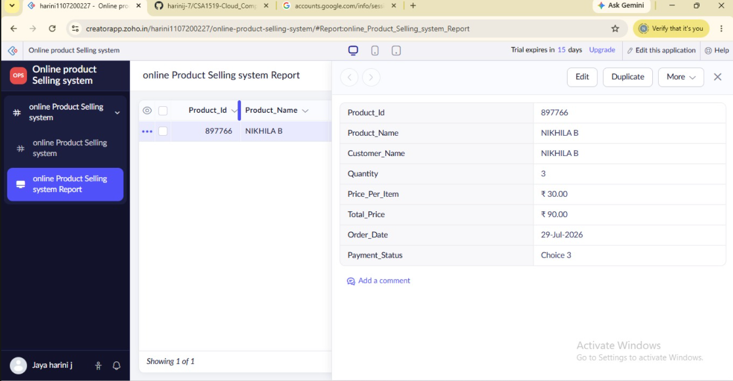
Result
The Online Product Selling Application was successfully created using Zoho Creator, allowing users to manage products, process customer orders, automatically calculate the total price, and store sales information through a cloud-based SaaS application.

